EC-341 Digital System Design
BS(CE)-2021
LAB REPORT # 07

Submitted By:
Reg. No. | Name
21-CE-009 | Huzaifa Shahbaz
21-CE-021 | Yawar Ali Malik
21-CE-020 | Muhammad Ibthesam Khan

Department of Computer Engineering
BS Computer Engineering Program
HITEC University Taxila
 | Presentation  (Format(0.5)+Title (0.5)+  Conclusion(1)+Procedure(2)+Objective(1)) | Calculation/Coding | Observation/ Program Results | Total
Total | 5 | 5 | 5 | 15
Obtained

___________________________
Lab Instructor.
Engr. Fasih Ahmad
Experiment #07
Analysis of Implementation of Combinational Circuits Using Different Approaches (Design ALU)

Objective
- Combinational Circuits
- Implementation using ALU
- Comparison of Area Estimations
- Lab Tasks
Software Used
- Vivado
Tasks
Task 1
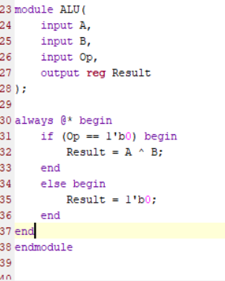

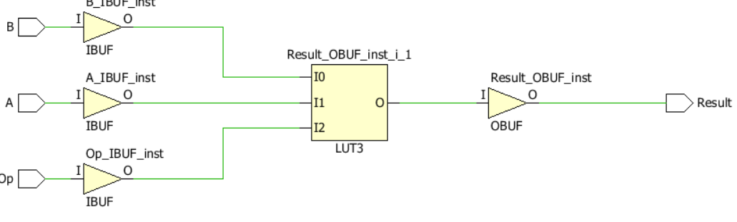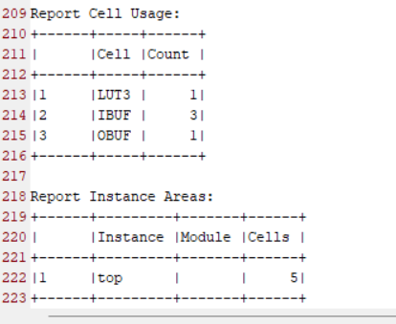
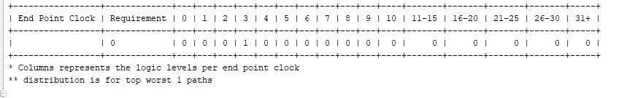

Task 2
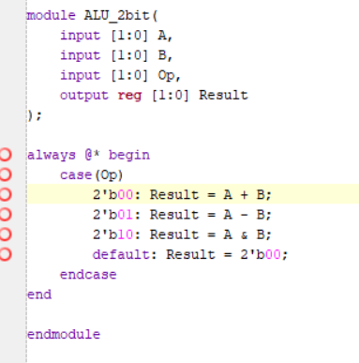
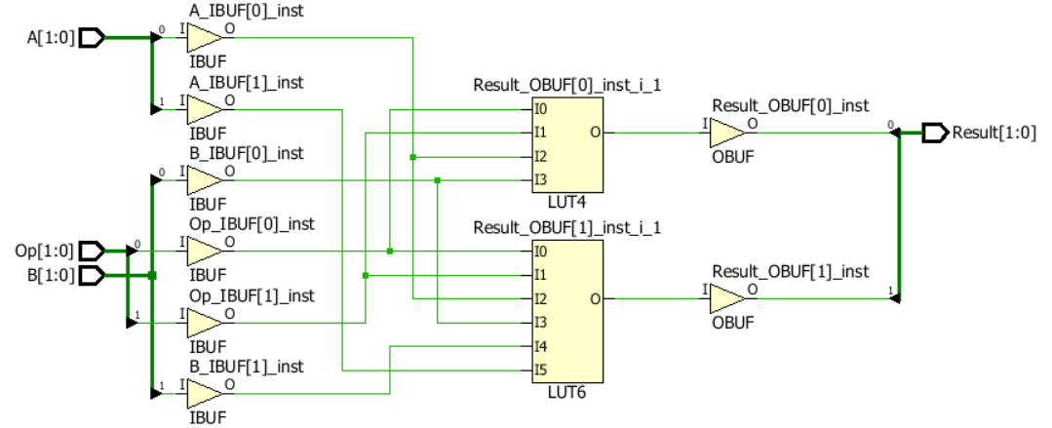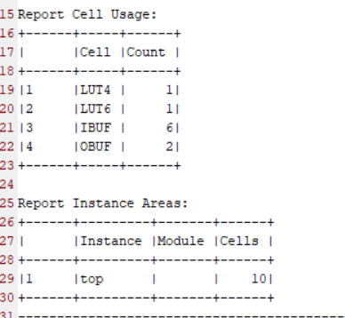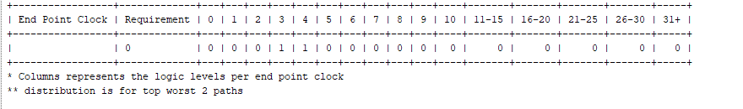
Conclusion
In this lab we implemented ALU capable of performing three operations: addition, subtraction, and bitwise AND.

